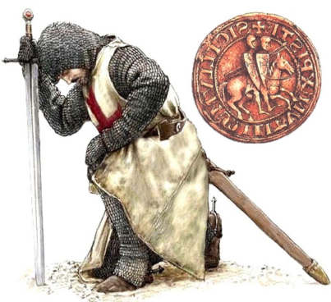
The
worldwide newburgh family
mapping and research project
DONATION FORM
Name_______________________________________________________________________
Address_____________________________________________________________________
City____________________________State___________________Zip________
Phone_____________________
Donation amount: __________________________
I wish to receive periodic updates on research.
THANK YOU FOR YOUR GENEROSITY.
WE APPRECIATE YOUR SUPPORT!
Mail to: P. O. Box 58333
Renton, WA 98058
I understand my donation will be used for research purposes in studying the Newburgh family of the United Kingdom; for acquiring archived documents and for translation of said documents. Donors will receive periodic updates on research if requested.

